At conference, saints seen as examples for today’s women
Zoey Di Mauro, Catholic Standard
Monday, March 23, 2015 3:44 PM
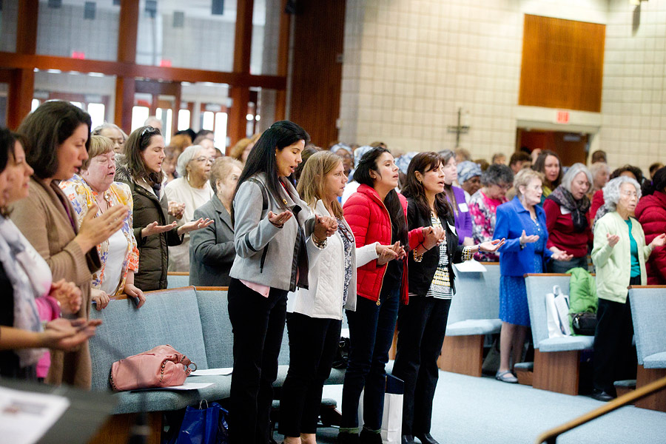
CS PHOTO BY JACLYN LIPPELMANN Women pray during Mass at the March 21 Women’s Conference sponsored by the Archdiocese of Washington.

Among the hundreds of churches in the eternal city of Rome are a few named after the women who originally lived there, who opened their homes so that worshippers could break bread with one another, Cardinal Wuerl told the more than 400 women gathered at the Archdiocese of Washington’s Women's Conference on March 21. As guardians of the hearth, women throughout the years have had the “privileged place of passing on the faith,” he said during the homily at Church of the Resurrection in Burtonsville. Commenting on the theme of the conference: “Gathering the Wisdom of Women: Water to Wine,” he urged each of the women to “never diminish in your own mind the importance of your wisdom.”
Cardinal Wuerl was the main celebrant for the Mass at the conference, where women could also spend time in Adoration with the Blessed Sacrament, go to Confession, or hear talks in both English and Spanish about growing in the faith. Women were able to meet and network with one another, or as Geraldine Broglio from Holy Family in Mitchellville did, run into old friends from other parishes, turning the conference into a “kind of a nice reunion.” For Guadalupe Pena of St. Joseph Parish in Beltsville, attending the conference was one way for her to fulfill her goal of constantly looking to “better our spiritual lives,” she said.
Dozens of Cameroonian women from St. Camillus Parish in Silver Spring came in matching blue and white skirts and dresses featuring images of the Virgin Mary. “Her color is blue and white… and we have to wear matching—white shoes, white beads, white pocketbooks—so that it looks good,” said Rose Achoh, president of the group. Described by one member as “soldiers for Mary,” the women came to the conference to “listen and learn,” said Achoh.
Rose Folsom came to connect with other Catholic women and to share about her project to promote the virtues, or what she calls “habits in ourselves of doing the right thing, of living in response to Christ's love. Virtue connects us with God, connection with God makes us happy, and so virtue leads to happiness,” she explained. A convert from “nothing-much-ism” to Catholicism in 1990, she is now a lay Dominican and a parishioner at St. Andrew Apostle in Silver Spring. “When I found the truth I was awestruck, and ever since then I can’t get enough,” she said.
Booths lined the hallways of the conference, like one on resources about Natural Family Planning. Another sold jewelry and other handcrafted, fair-trade items from Catholic Relief Services. The Franciscan monastery sold religious artwork and books, while the National Council of Women handed out brochures about knowing the signs of domestic abuse. Even greeting cards and T-shirts with encouraging Christian messages were available.
But besides religious goods and information the women took home the words of the speakers, like Colleen Carroll Campbell, a presidential speechwriter, author and journalist who gave the English keynote address. Borrowing from her newest book My Sister the Saints, she explained how she has journeyed from seeing the saints as “too dewy-eyed and cherubic to relate to...the stars of pious fairy-tales,” then to knowing them as “real flesh and blood people worth befriending.”
She learned from St. Therese of Lisieux to “bloom where you’re planted,” that everyone is called to holiness wherever they are and that every little thing can be done with great love. She learned from Blessed Mother Teresa to have a heart that “holds nothing back for itself.” She learned from St. Francis of Assisi to constantly grow in her faith, from a man who “loved Jesus too much to settle for good enough. Love can never be content for long to stay where it is.”
Lucia Luzondo, the Spanish keynote speaker also talked about the importance of true love which allows “no just in case, no Plan B,” whether it’s loving a husband whose lush head of hair has turned into “an ample landing pad,” or simply supporting a friend even when it becomes annoying or difficult. “A wise woman knows true love and gives true love freely… they are a source of peace,” she said. She asked the women to pray for wisdom, for good judgment which allows you to “see everything through the eyes of God.”
She and her husband Ricardo, the only male speaker at the conference, had to see with the eyes of God when they left their careers, hers as a lawyer and his as a doctor, to become full time missionaries for the Lord and speak at retreats and conferences like this one. Other speakers spoke about cultivating peace, Mary in art and the wisdom of grandmothers. Broglio felt that she was “guided” to the breakout sessions that were “really pertinent to me. I hope that the blessings from today will continue for this whole group of people. It helped me a lot,” she said.

